|  |  |
| --- | --- |
| For office use only | |
| T1 |  |
| T2 |  |
| T3 |  |
| T4 |  |

|  |
| --- |
| Team Control Number  **65108** |
| Problem Chosen  **C** |

|  |  |
| --- | --- |
| For office use only | |
| F1 |  |
| F2 |  |
| F3 |  |
| F4 | _ |

**2017 MCM/ICM Summary Sheet**

Self-driving cars, considered as practical tools to solve road congestion problem, have become more and more popular. It will benefit a lot to study how the effects vary with the percentage of this kind of car. We build a series of models to study this issue.

Though our model, we think the differences between self-driving car and manual-driving car mainly lie in the less reaction time and shorter time gap which directly affects the maximum traffic flow.

First, we have referred to a mixed traffic flow model, which is used to work out the capacity of a road with trunks and taxis. Considering taxi and self-driving car both have shorter time gap and reaction time than trunk and manual-driving car, we innovatively apply the mixed traffic flow model to discuss self-driving and manual-driving cars, and successively get the capacity of a single lane. Furthermore, in order to verify the former model, we use AIMSUN 8.1(a traffic simulation tool) to simulate the single lane situation. Then we implement a model based on the theory of gap acceptance, considering how the traffic flow will merge into the main lanes, and get the curve of hourly traffic counts against percentage of self-driving cars.

Then, we propose max-flow algorithm and develop it by adding the intersection capacity to work out the maximum traffic counts of the whole network. We find that when p = 10%, the capacity will improve by 1%, when p = 50%, the capacity will improve by 20% while when p = 90%，the result improves by 81%. By observing the curves and the difference of capacity, we find the tipping point is around 50%.

To verify our conclusion, we use AIMSUN 8.1 to simulate the whole network situation. The simulation shows that the conclusions we get from our model is amazingly true!

Furthermore, we use road impedance function to determine whether lanes should be dedicated to these cars. Through comparing the total driving time in designated lane situation with that in former situation, we find that when 0.2<p<0.4, it is suggested to set a designated lane for self-driving cars.

In the end, we present a letter to the governor and recommend to put 50% of self-driving cars in the Greater Seattle Area. In this case, we needn’t dedicate a lane for self-driving cars.

**Key words: self-driving car, time gap, AIMSUN 8.1, max-flow algorithm.**

1. **A Letter to the Governor’s Office**

Dear Governor,

We’re writing to you to express our suggestions on the self-driving car problem. Given the apparent promise that self-driving cars can contribute to congestion reduction, we implement a series of mathematical models around self-driving cars to answer your questions. The Interstates 5, 90, 405 and State Route 520 are involved in the problem.

We build a novel model using max-flow algorithm based on two parts – single lane and intersection. By simulating our model with AIMSUN 8.1, we get a closer result and can safely draw our conclusions on the relationship between capacity of the network and percentage of self-driving cars.

Here we want to recommend three concrete actions to address these issues:

1. Put 50% self-driving cars into the traffic system.

In our study, we find that when p = 10%, the capacity can improve by 1%, when p = 50%, the capacity can improve by 20% while when p = 90%，the result improves by 81%. By observing the curves and the difference of capacity, we find the tipping point is around 50% where the capacity of the network can be improved most significantly. So we think the best choice is putting 50% self-driving cars in the traffic system, which may be implemented by modifying the traffic configuration.

1. Set the designated lanes for self-driving car under the following conditions:

Based on our calculation results, we suggest that when the percentage of self-driving cars are between 0.2 and 0.4, such a designated lane should be set for it.

1. Give a specific policy on the licensing.

Considering the breakout of the self-driving car, we should evaluate the driver’s ability to stop the car safely. Furthermore, we can establish a complete legislation for the qualification of licensing.

1. Properly preserve the traffic data.

We should know that the traffic data can show a person’s route, so we should stress the privacy of these traffic data. Who should be in charge of these data? Where do the data save? How can we make sure not letting out the data? These problems need to be solved before putting the self-driving car into the market.

Self-driving car can not only reduce congestion but also improve the traffic safety, therefore putting it into the market can benefit a lot. Before using it, some specific policies are urgent to be given.

Best,

Team 65108.

# Introduction

In the modern transformation system, increasing cars lead to more and more congestion phenomena. Self-driving, considered as the contribution to congestion reduction, has become more and more popular.

Self-driving cars, acting like cooperative vehicles, can get the whole traffic information from an intelligent system and take optimal action referring to that information.

In order to find out the best plan to put this kind of vehicle into the traffic system in the Greater Seattle area, we were given some road data of the particularly congested Interstates 5, 90, 405 and State Route 520.

How can we study them? Specifically, we tackle five main sub-problems as follows:

* How do the effects change as the percentage of self-driving cars increases on a single lane?
* How do the effects change as the percentage of self-driving cars increases on the intersection?
* How do the effects change as the percentage of self-driving cars in the whole road network? Based on this, we should find whether there exists a tipping point where effects changes markedly.
* Under what conditions should lanes be dedicated to these cars.
* Do we need to modify the current policy depending on our analysis?

# IV Assumptions

* We suppose that the self-driving cars applies CACC system
* We consider the road network as a closed system in topology

There are only 4 roads (Interstates 5, 90, 405 and State Route 520) in the system. Thus we neglect the freeway of the other road when dealing with the topological problem. But we will consider the intersection when solving the sub-problem 2

* We neglect the types of vehicles, only classify it into 2 parts – self-driving cars and the other

The ordinary vehicles cannot link up to the intelligent system, the drivers are only reflected by individual priority principle

* There is no traffic light, toll station or fork on the 4 roads
* We neglect the traffic accidents and other emergencies
* The distribution of self-driving cars is a uniform distribution
* Based on the domination principle, we assume the time gap of self-driving car as 0.5s

# V Model Overview

To explore the effects when adding self-driving cars to the 4 roads, we build a series of models to solve the five problems we tackled.

At first, we study the effect on the single lane based on a classical traffic flow models – mixed traffic flow model. It’s applied to trunks and taxis but can be successfully used in discussing self-driving cars and manual-driving cars because of the common property they have. That is, self-driving cars and taxis both have much shorter time gap and reaction time.

After dealing with the basic model, we propose a extended model to simulate the manual driving situation. Combining the CACC model and our model, we use *AIMSUN 8.1* to simulate the single lane situation and get the curve of average hourly traffic counts and percentage of self-driving cars.

In the second place, we implement the theory of gap acceptance to propose an innovative model to solve the effects of intersection. For diverge intersection, we cannot allot the traffic flow. Hence, we only consider the merge intersection. And we can also get the curve of hourly counts and percentage of self-driving cars.

Third, in order to evaluate the traffic capacity of the whole road network, we efficiently transfer it to a max-flow problem in topology. We develop the max-flow algorithm by regarding the intersection as a one-direction arc. The final result of the relationship between network traffic capacity and the percentage of self-driving cars is vividly shown by a histogram.

Fourth, based on the first and second step, we make a comparison between having self-driving car lanes and not having it separately on single lanes and intersections. We calculate the different whole driving time by the Road Resistance Model and determine whether construct such an accommodation lane.

Last, we use the result we get and the rule we make on the intersection to compare with the traffic configuration of Washington, and finally attain which traffic rule is a must to change.

# VI Model Implementation and Results

## 6.1 Sub-problem 1: How the effects change of a single lane?

### **Basic model**

We use the mixed traffic flow model reference to start our study.

The mixed traffic flow model is widely applied to deal with the car following problem between trucks and taxis. Why can we use it in our model?

Trucks are much heavier than taxis, thus they have much longer time gap and greater inertia, which turns into longer reaction time. As has stated in the introduction that the main difference between self-driving car and manual-driving car lies in the time gap and reaction time. We can reasonably consider self-driving cars as taxis while manual-driving cars as trucks.

We propose the following reasonable assumptions:

* There exists no overtaking
* When traffic flow is in an equilibrium state, the speed of self-driving cars as well as the manual-driving cars are the same, the accelerated speed of one type is the same and constant.
* When the leader slow down by accelerated speed a, the follower will also slow down by the same a.

First, we set the ratio of self-driving car to manual-driving car is to , the reaction time to the two types are separately and .

As figure shows the time gap in car following model, , and separately denote the time gap. When there are only self-driving or only manual-driving cars on the road, we have =.

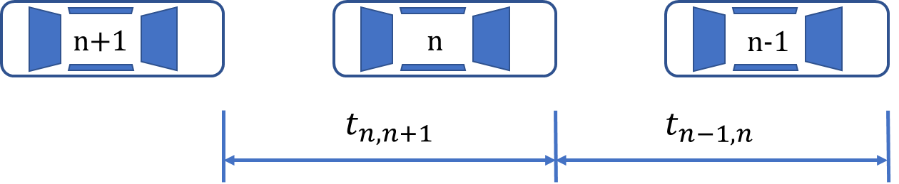

**Figure : Time gap in the car following model.**

According to the mixed traffic flow model, =0.9s;=1.5s;=1.8s;=1.9s.

Because of the stochastic combinations of adjacent cars, we consider the appearance of self-driving and manual driving cars are independent incidents. Thus we get the probability like:

We develop as the time gap of combination vehicles like this:

Consider the formula of road capacity, we change the type to get the traffic counts per hour instead of per second.

In this situation, the formula above turns into the following type:

Last, we get the relationship between road capacity and percentage p.

|  |  |  |  |  |  |  |  |  |  |  |  |
| --- | --- | --- | --- | --- | --- | --- | --- | --- | --- | --- | --- |
| p | 0 | 0.1 | 0.2 | 0.3 | 0.4 | 0.5 | 0.6 | 0.7 | 0.8 | 0.9 | 1 |
| C | 1894.737 | 1951.22 | 2022.472 | 2111.437 | 2222.222 | 2360.656 | 2535.211 | 2758.621 | 3050.847 | 3444.976 | 4000 |

**Chart : The relationship between capacity and percentage in single lane.**

### **Extended model**

In order to verify the result from our basic model, we develop an extended model where the result can be reached by simulation on AIMSUN 8.1.

1. CACC modelling

We analyze the performance of one self-driving car in a microscopic way based on Cooperative Adaptive Cruise Control (CACC). To do that, we find that the traffic flowrate has positive correlation with time gap. The main difference from CACC to manual driving is the shorter time gap and shorter reaction time.

CACC is an intelligent system where the car can get information from the whole road network. The rule of it can be simply depicted as follows: In a single lane, (1) if the distance between two cars are larger than 120m, then it starts the speed control to get closest speed to the limit speed of the road or the drivers set in the system before, (2) when the distance is smaller than 100m, then it starts the gap control to keep the desired gap between two cars, (3) when it varies from 100m to 120m, the system maintains the state of the last period.

CACC modelling is a classical modelling from the microscopic way, for the two different mode mentioned above, it has different rules of accelerated speed.

Here is the chart of nomenclatures we use in the CACC modelling.

The formula is presented as follows:

It’s the speed error, when in the speed control, we expect to turn to 0, but in the real situation, one cannot put the accelerated speed too large in order to avoid accident, thus we set the bound as (-8,2), so we get a formula of accelerated speed:

We consider that the desired gap has positive correlation with the desired time gap:

In the gap control mode, represents the gap error:

For the same reason in the speed control mode, we set a bound (-8, )

Reference

2. Manual modelling

In this part, we develop a manual modelling based on the disturbance of a longer reaction time, which turn to a longer time gap.

The process is as follows:

These are the nomenclatures for manual modelling.

|  |  |
| --- | --- |
| nomenclatures | definition |
|  | upper bound and lower bound for the clearance between vehicles |
|  | vehicle sequence ID |
|  | kinematic wave travel time |
|  | jam gap |
|  | length of vehicle |
|  | acceleration of vehicle |
|  | speed of vehicle |
|  | position of vehicle |
|  | free flow speed |

**Chart : Nomenclatures for the manual modelling.**

3. Simulation method

We use the simulation method to solve the effects change based on the CACC and manual modelling. The experimented road is a 6.5-km-long single lane with limit speed 105 km/h. There are two types of the simulated objects – cars with CACC system and cars without that. We set the parameter of both CACC and non-CACC cars as the same. The length is 4.7m and width is 1.9m. The boundary of accelerated speed is (-8,2).

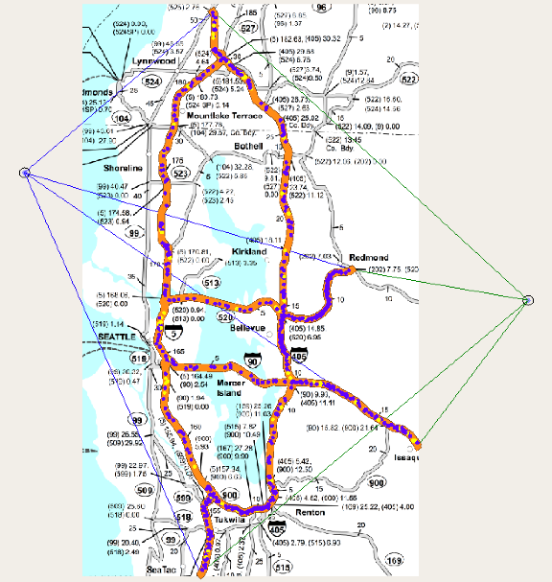 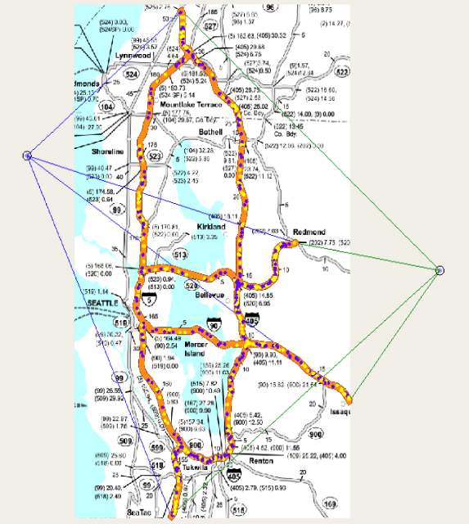

**Figure : 10% self-driving cars**  **Figure : 50% self-driving cars**

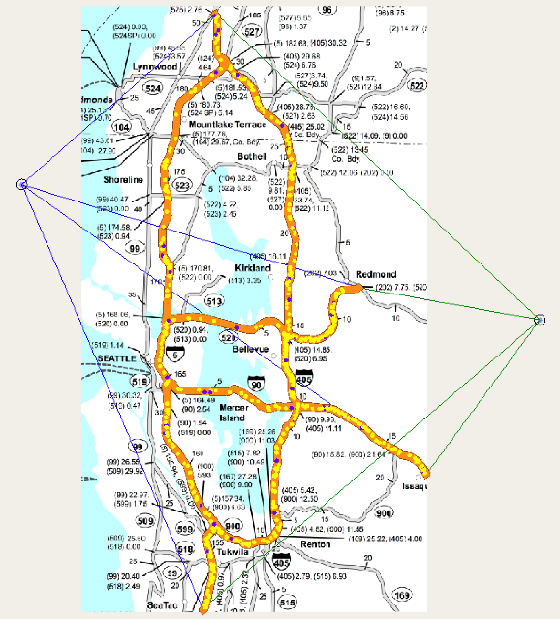

**Figure : 90% self-driving cars**

The three figures vividly show the traffic situation when self-driving car is added into the network in the Greater Seattle. The yellow cars denote self-driving cars while the blue ones denote manual-driving cars.

**Figure : The corresponding histogram of the relationship on single lane.**

We then compare the curves between the basic model and extended model. The blue curve represents the simulation result while the red curve represents the basic model’s result.

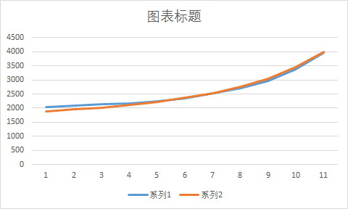

**Figure : Two curves from the two models.**

From figure , we can safely draw the conclusion that the basic model can get an accurate result.

**6.2 Sub-problem 2: How the effects change of intersections?**

We find the relationship between maximum traffic flow and percentage of self-driving cars in the single lane situation. In order to find the traffic capacity of the whole road network, we should analyze the relationship in intersection situation.

We should realize that the intersections given by the Excel spreadsheet can be classified into two types – the merge situation and diverge situation.

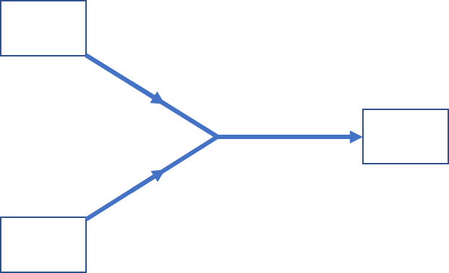 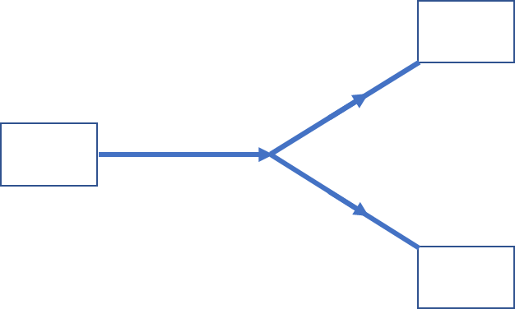

**Figure : the merge and diverge situation in intersection.**

In the diverge situation shown in figure , we cannot decide which road branches to enter for the traffic flow on the main road. Thus, in the congestion situation, considering the diverge situation is meaningless. Now we mainly study how the effects change when congestion happens in the merge situation of an intersection.

1. Basic model

A multi-lane freeway shown in figure , we can implement the theory of gap acceptance to simulate the merge situation. What we should stress is that the main lane 1 and 2 are sets of several lanes instead of one single lane.

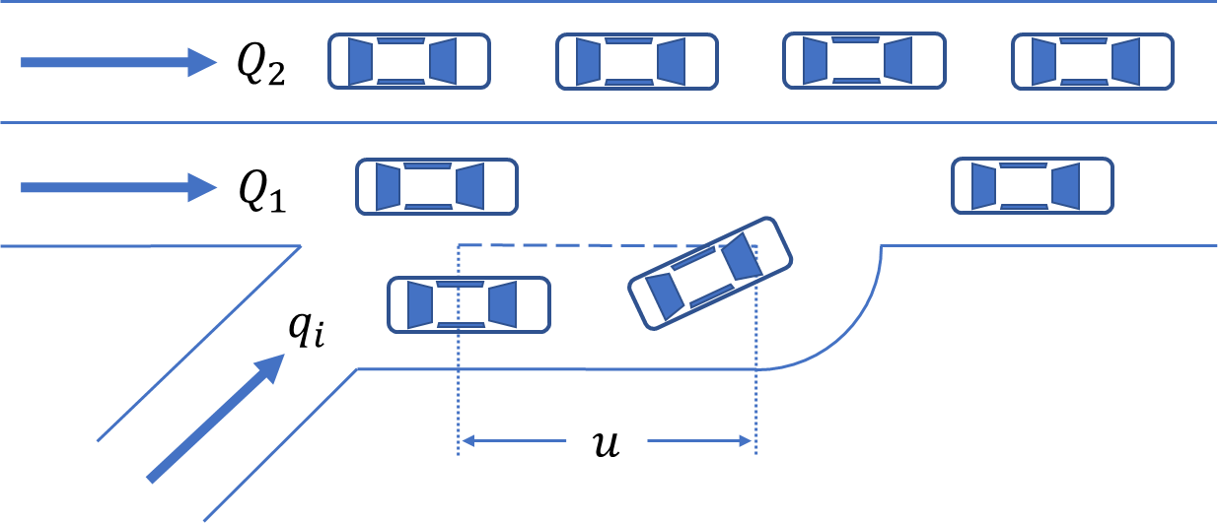

**Figure : multi-lane freeway merge situation.**

|  |  |
| --- | --- |
| Nomenclatures | Descriptions |
| L  Q | Length of the acceleration lane.  The time of one car merging into the main road.  The time of continuous traffic flow merging into the main road.  The traffic capacity of the main road.  The traffic capacity of the ramp.  The vehicle flowrate of the main road before merging.  Traffic share ratio of the inside lane (lane 2).  Traffic share ratio of the merging main lane (lane 1) |

**Chart : Nomenclatures of model 2**

We add the impact of acceleration lane into our model by the following process:

When cars reach the intersection in merge situation, they wait for merging into the main road. Cars on the acceleration lane and cars waiting for merging can find the time interval to merge into the main road, therefore cut down the time cost, we set the extra time interval as . Suppose that the speed of cars is the same on the same lane. We set the speed on the outside lane as , the speed of cars before entering the intersection is , the average accelerated speed is a. By using the knowledge of kinematics we can get the time covering distance L in the acceleration lane as follows:

=

If the speed is , we can certainly get the time as

So the extra time interval is

=-

First, we analyze the traffic flowrate of the main roads, thereby we can find the transferred traffic volume.

The traffic flowrate of the outside lane is

=(1-)Q

The traffic flowrate of the inside lane is

=Q

According to reference, when there exists no traffic light in the intersection, we think the vehicles on the tramp will have higher priority to enter the main road. The time gap between vehicles has a negative exponential distribution. The traffic flowrate of the inside lane can never reach the maximum capacity . So there exists traffic transformation between inside road and outside one. The transferring traffic volume is

The theory of gap acceptance displays the formula of maximum transferring volume

|  |  |
| --- | --- |
| Nomenclatures | Descriptions |
| q  h(t)  g(t)  Q | Maximum traffic volume from tramp to main road.  A period of time.  The distribution of time gap on the tramp.  The distribution of the probability that vehicles on the tramp can merge into the main road.  The traffic flowrate of the main land in a unit time. |

**Chart : Nomenclatures of the gap acceptance theory.**

Then, we use the theory of gap acceptance to quantize the effects change the self-driving car brings. From our model 1, we know that the percentage of self-driving cars p has positive correlation with the time gap between vehicles, thus we can figure out by p.

Consider the time interval , in our model it’s the peak hours and we set this as 4 hours. If we know the traffic flowrate of the outside lane is , while that of the merging traffic flow is .

According to the gap acceptance theory, we can get :

=

To simplify the result, we set A=, B=

The formula above turn to a simpler type:

According to reference, the time interval for one car and continuous cars are separately and , where

We set the speed v as 90km/h referring to the traffic configuration of Washington [reference].

Thus, by the combination of formula ( ………) , we can get the flowrate of one tramp merging into the main road. The results can be found in the following chart.

|  |  |  |  |  |  |  |  |  |  |  |  |
| --- | --- | --- | --- | --- | --- | --- | --- | --- | --- | --- | --- |
| p | 0% | 10% | 20% | 30% | 40% | 50% | 60% | 70% | 80% | 90% | 100% |
| Q | 2027 | 2098 | 2135 | 2167 | 2231 | 2338 | 2532 | 2699 | 2965 | 3389 | 3980 |
|  | 318 | 346 | 449 | 650 | 889 | 916 | 743 | 729 | 534 | 313 | 181 |
|  | 2345 | 2444 | 2584 | 2817 | 3120 | 3254 | 3275 | 3428 | 3499 | 3702 | 4161 |

**Chart : The result of one tramp in the merge situation.**

**Figure : The histogram of relationship between capacity of intersection in one tramp and percentage of self-driving cars.**

**Figure : The curve of the relationship ( red one represent the curve and blue one represent the change)**

In order to verify our model, we use AIMSUN 8.1 to simulate the intersection model. The yellow one represent self-driving cars while blue one represent ordinary cars.

The simulation shows that the 50% is the best percentage to reach an optimal traffic flowrate.

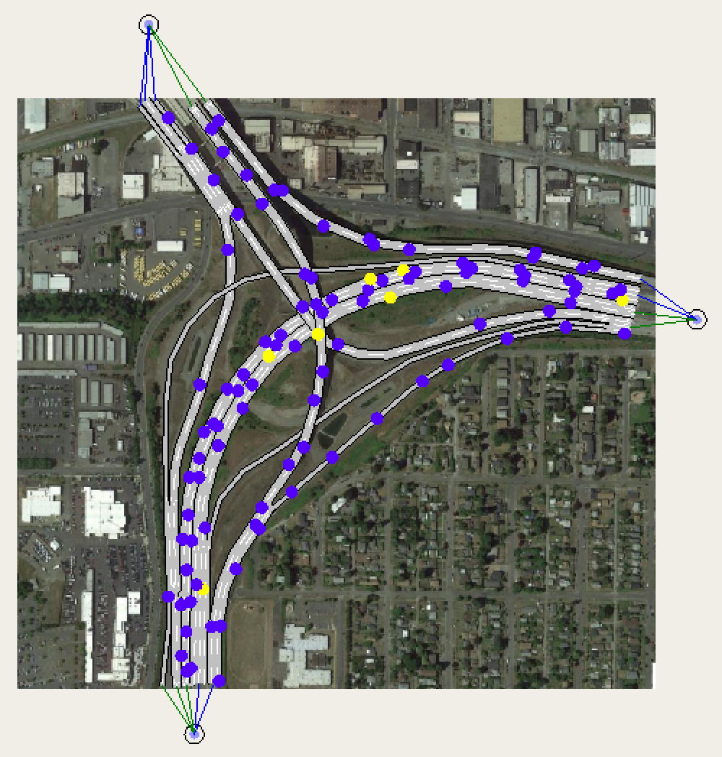 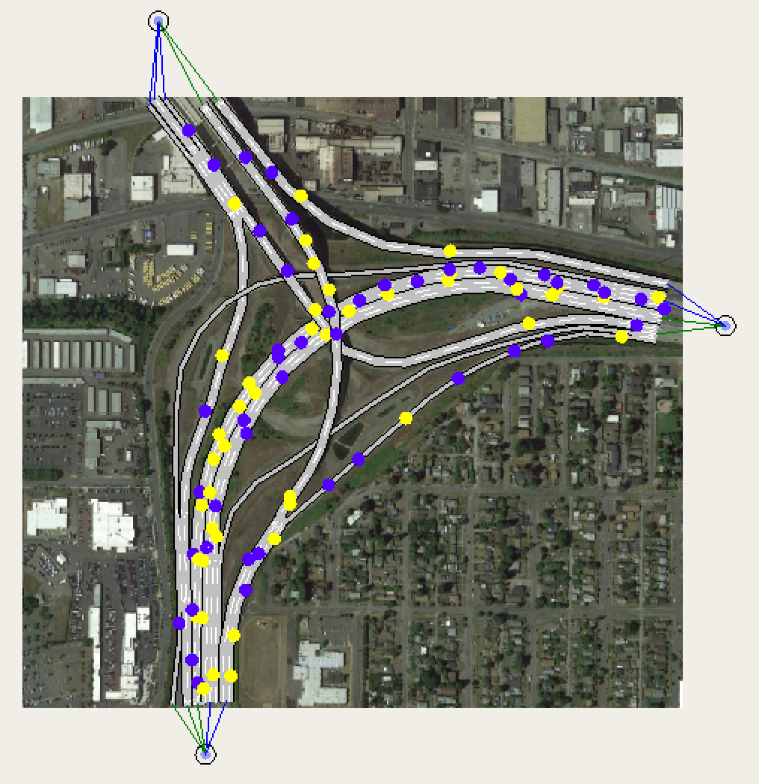

**Figure : 10% self-driving cars Figure: 50% self-driving cars**

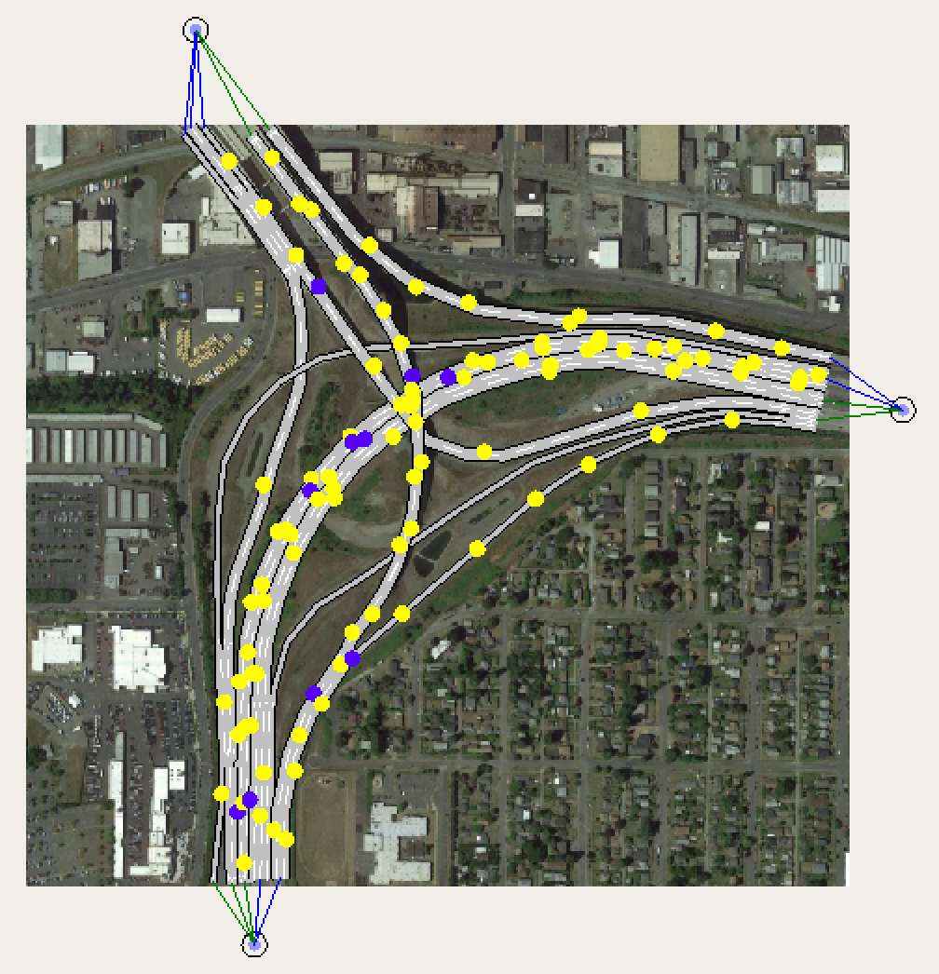

**Figure : 90% self-driving cars**

## 6.3 Sub-problem 3: How the effects change of the whole network?

**1. The modified max-flow algorithm**

We want to get the final result of how the percentage of self-driving cars can impact the traffic capacity of the whole network.

From model 1, we can get the traffic capacity of each ordinary single lane, while from model 2, we can also get the curve between traffic capacity of intersections and percentage of self-driving cars. Applying the result of model 1 and model 2 to the max-flow algorithm, we only need to add the intersections into the oriented graph. The result of the capacity based on some designated percentage p is denoted by .

Using the real data from the Excel spreadsheet, we can get the real traffic volume of each ordinary single lanes and intersections. Also put in the values of traffic volume and we can get a value denoted by , representing the traffic volume of the whole network.

In conclusion, we set a standard to quantize the capacity of the whole network by topological method. A developed max-flow algorithm is used to solve the problem. Each time you change the percentage of self-driving cars, you can get totally different capacity of each single lane and intersection, thus the capacity solved by our algorithm is also different.

The source code of our developed max-flow algorithm is as follows:

GetMaxFlow

**for** each edge

begin

end

**while** there exists a path from to in the residual network （Find the path by using BFS( Breadth-First-Search )）

begin

**for** each edge in

begin

**if**

**then**

**else**

**then**

end

refresh the by adding the of this loop to it

**for** each edge in

begin

**if**

**then**

**else**

**then**

end

end

The is the answer

**2.Result of curves and tipping points**

Now we will deal with road data from the Excel spreadsheet.

First figure out the curve of interests on the single lane.

1. We assume that on average, 8% of the daily traffic volume occurs during peak travel hours
2. Set the number of increasing direction lanes as n, number of decreasing direction lanes as m. When we want to find out the average daily traffic counts x of each lane, the basic assumption we propose is that we think the traffic jam only happens in one direction at the single peak time of congestion. The situation where congestion happens on both directions is very rare. We naturally come out a conclusion that there exists peak time in the morning and night, which turns into two opposite-direction congestion, therefore we can get x by the following formula:

Then work out the curve of interests on the intersection in merge situation.

1. From the Google’s live map, we find that each node has a series of intersections.

Based on the result of model 2, we can get the capacity of the intersections, which are consisted of several merging situations.

1. The capacity of an intersection equals to the minimum value of the theoretical maximum input and the theoretical maximum output. Since the output condition has the merging situation, the theoretical maximum output will be smaller than the theoretical maximum input. So, the capacity of an intersection equals to the sum value of the maximum output of each road that is connected to that intersection.

The formula is:

Results

1. Take the real daily average into this improved max-flow algorithm, the max flow is 7786.

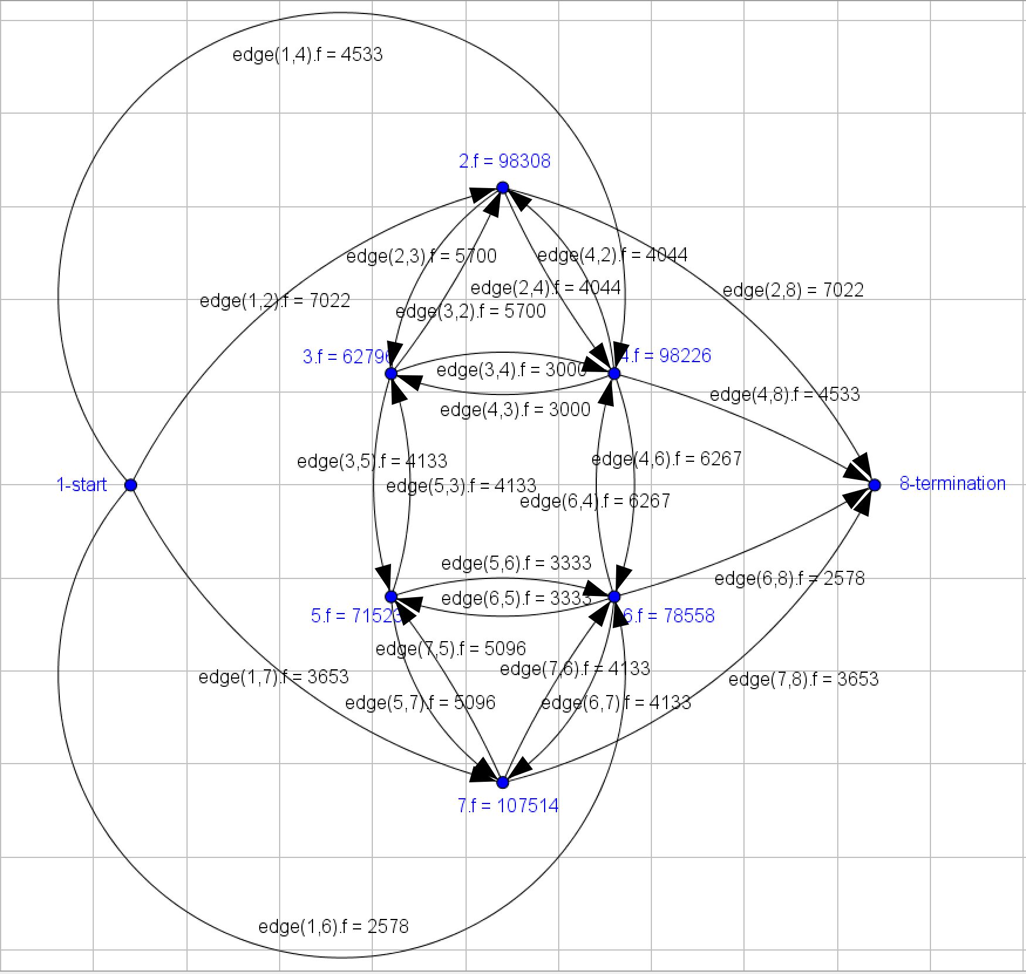

**Figure : The max-flow algorithm dealing with the real data.**

1. Take the percentage of self-driving cars from 10% to 90%, the interval is 10%, then fit a curve like the following figure:

|  |  |  |  |  |  |  |  |  |
| --- | --- | --- | --- | --- | --- | --- | --- | --- |
| 10% | 20% | 30% | 40% | 50% | 60% | 70% | 80% | 90% |
| 9755 | 10110 | 10555 | 11110 | 11800 | 12670 | 13790 | 15250 | 17220 |

**Chart : The capacity of the whole network depending on percentage p.**

**Figure : The fitting curve according to the chart above.**

## 6.4 Sub-problem 4: Should lanes be dedicated to these cars?

First we assume there exists a dedicated lane for self-driving cars. This problem is decided by the whole network, thus, we should dedicate the designated lanes for all the roads in the network and the numbers of lanes should be the same on each road.

Then we will develop a new model based on the Road Resistance Model reference

In this formula, is the time driving through this road:

C is the maximum capacity of the road while v denotes the real traffic volume of this road.

are two parameters whose empirical value is separately 0.15 and 4.

Now we will measure the capacity of different types of lanes by the driving time.

1. The designated lanes for self-driving cars

The vehicles are all self-driving cars, thus we can easily get the average driving time by

Considering the proportion of self-driving cars, the traffic flowrate of this lane *v1* and that of the whole road v satisfy this equation:

*v1=v*p*

1. The other lanes.

The traffic volume v-v1 is divided in (n-1) lanes, so the average driving time is

After analyze the average driving time, we further discuss the whole driving time for a road. Before setting a designated lane, the whole driving time is

After setting such a lane, the whole driving time changes to :

Last, for each specific percentage p, we can compare the value of and 1.

If , we don’t choose to dedicate such a lane for self-driving cars. On the contrary, when , the conclusion is to set a designated lane.

For the whole network, whether to dedicate such a lane should take average hourly traffic counts into consideration.

Conclusions

According to the four formulas above, we calculate the average hourly traffic counts and its ratio. The result is shown in the following chart.

|  |  |  |  |  |  |  |  |  |  |  |  |
| --- | --- | --- | --- | --- | --- | --- | --- | --- | --- | --- | --- |
| Percentage | 0 | 0.1 | 0.2 | 0.3 | 0.4 | 0.5 | 0.6 | 0.7 | 0.8 | 0.9 | 1.0 |
|  | 0.66 | 0.79 | 1.02 | 1.01 | 1.03 | 0.82 | 0.59 | 0.38 | 0.23 | 0.14 | 0.1 |

**Chart : The result for the fourth model.**

From the chart above we can see that the percentage from 0.2 to 0.4 have a corresponding time ratio larger than 1. Thus we can safely say that when the percentage of self-driving car varies from 0.2 to 0.4, it’s better for us to dedicate a lane for self-driving cars.

* **6.5 Sub-problem 4: Do we need to modify the current policy?**

Based on the conclusions of our models, we want to modify the current policy for two main ways.

First and foremost, it should be allowed for self-driving cars to have shorter time gap and distance.

Second, although our model neglect the safety problem such as the self-driving car breaking down, it’s really need to be stressed that what kind of people can have a license for self-driving car.